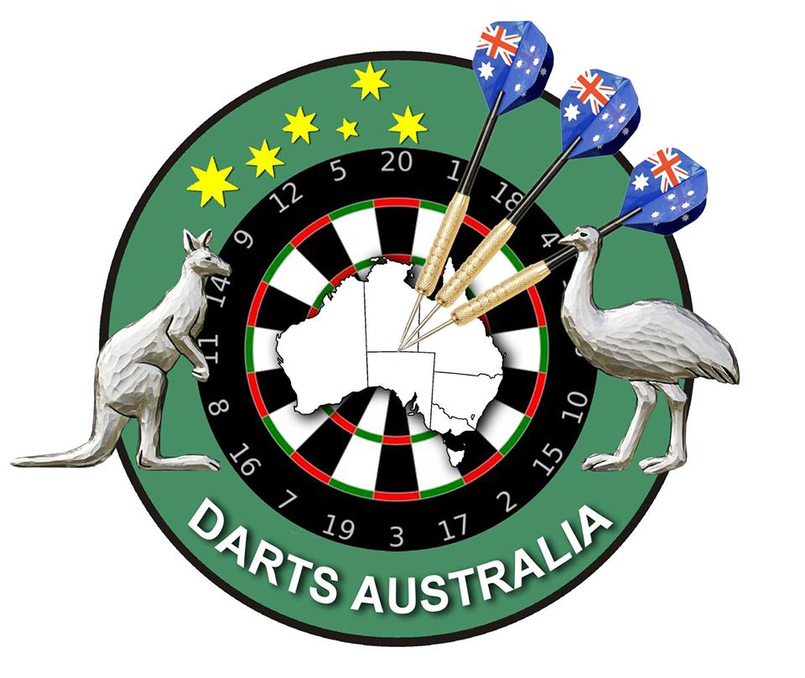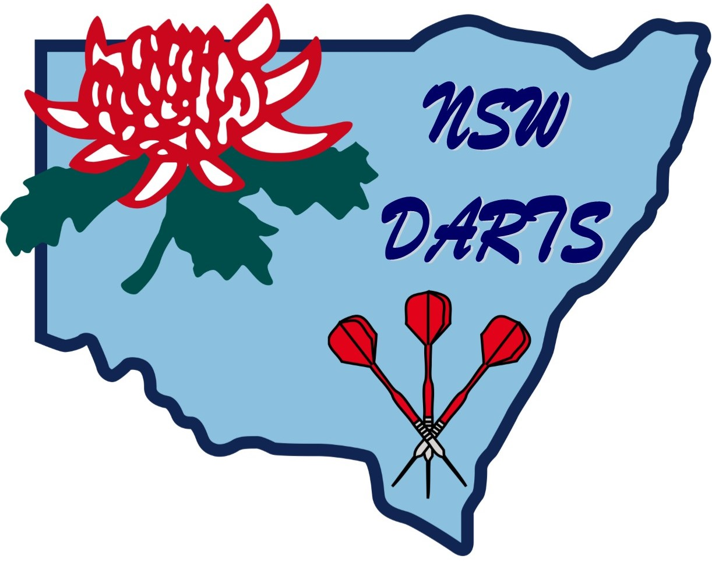
AUSTRALIAN CLASSIC

Total Prize Money
$7,000.00

(Doubles) 26th & (Singles) 27th June 2021
DA & NSW Darts Conditions of Entry
Entry Fee includes DA & NSW Darts Sanction Fees
UNSEEDED
PRIZE MONEY SUBJECT TO ENTRIES
MEN’S DOUBLES

1st $500.00 per team
2nd $200.00 per team
3rd-4th $150.00 per team
5th-8th $80.00 per team

Men’s Entry $30.00 per team
LADIES DOUBLES

1st $500.00 per team
2nd $200.00 per team
3rd-4th $150.00 per team
5th-8th $80.00 per team

Ladies Entry $30.00 per team
MEN’S SINGLES

1st $700.00
2nd $400.00
3rd-4th $250.00
5th-8th $150.00
9th-16th $60.00
Highest Peg $25.00
Most 180’s $25.00

Men’s Entry $15.00 per player
LADIES SINGLES

1st $600.00
2nd $300.00
3rd-4th $200.00
5th-8th $100.00
Highest Peg $25.00
Most 180’s $25.00

Ladies Entry $15.00 per player

Nominations Close
Doubles 9.30am Saturday 26th June Singles 9.30am Sunday 27th June

ALL ENTRIES TO: Contact Bob Weaver
Central Coast Leagues Club Darts Phone: 0412 050 448
Dane Drive, Email:
GOSFORD NSW 2250 bobweaver@optusnet.com.au
Phone: 02 4325 9888
Fax: 02 4325 9873

